Autoregressive Conditional Heteroskedasticity

Abbr

ARCH

Intro

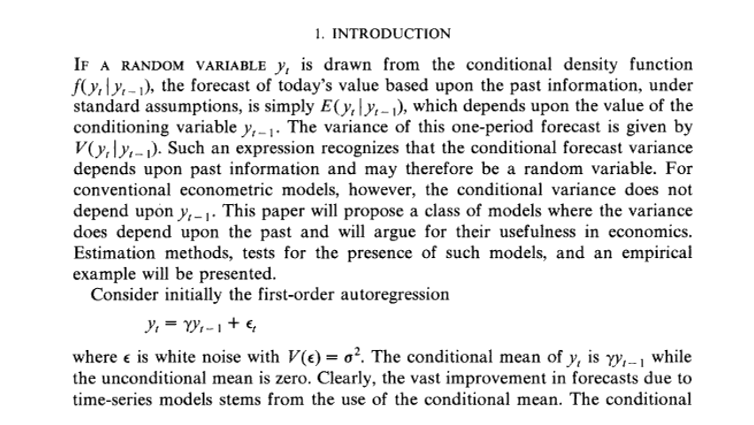

Model Specification

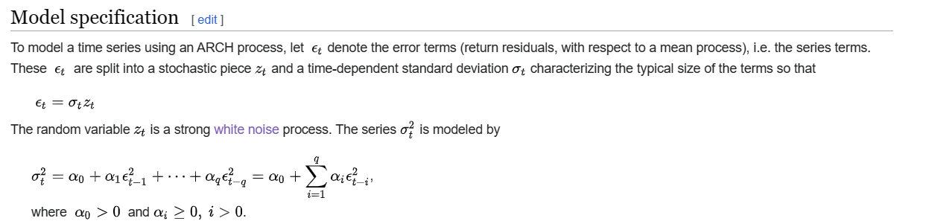

Given random variable $$z_{t}$$ which is a strong white noise process. The series

$$std{\left(\right)}_{t}^{2}$$ is modeled by

$$std{\left(\right)}_{t}^{2}$$

= $$alpha_{0}$$ + $$alpha_{1}⋅eps{\left(\right)}_{t−1}^{2}$$ +... + $$alpha_{q}⋅eps{\left(\right)}_{t−q}^{2}$$

= $$alpha_{0}$$ + $$sigma\left(alpha_{i}⋅eps{\left(\right)}_{t−i}^{2},i=1,i=q\right)$$

where

$$alpha_{0}>0$$ and $$alpha_{i}≥0$$ for $$i>0$$.

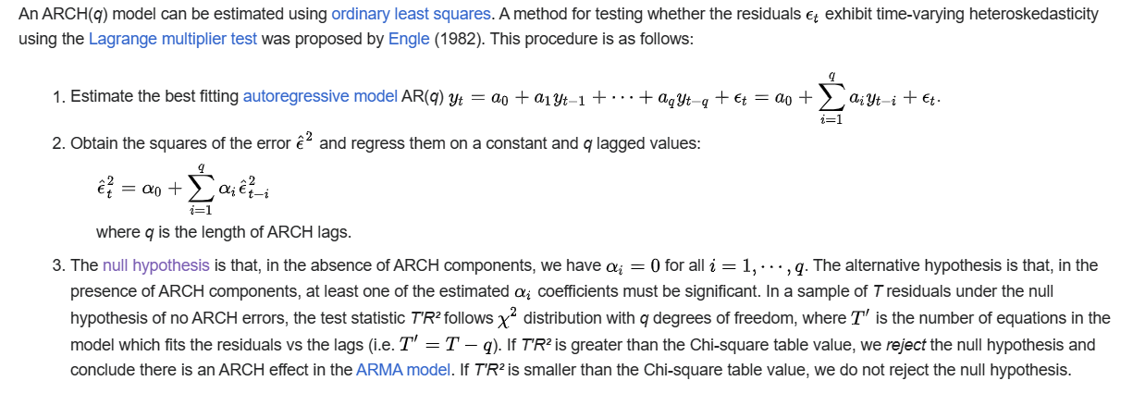

To use a ARCH(q) model.

1. Estimate the best fitting AR.
2. Obtain the square of the error $$head{\left(eps\left(\right)\right)}^{2}$$ and regress them on a constant and q lagged value.
3. Perform null hypothesis. Then get value for null hypothesis. Here, the null hypothesis in absence of ARCH components, one has $$alpha_{i}=0$$ for all $$i=1,…,q$$
4. Compare the result with corresponding value in CHI-squared table.
5. Determine it falls in accept area or reject area.

Case 1:

$$T^{′}R^{2}$$ > critical point => reject area

Case 2:

Otherwise => accept area

where

$$y_{t}$$ refers the conditional variance at time $$t$$. The reason why it is called conditional variance is that it depends on conditional variance at $$t−1$$ according to the following figure.

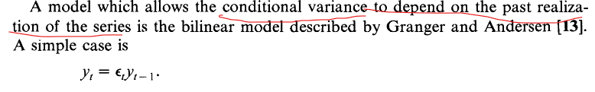

Ref

A website with simpler , boarder but less detailed intro -- Wiki.

[Autoregressive conditional heteroskedasticity - Wikipedia](https://en.wikipedia.org/wiki/Autoregressive_conditional_heteroskedasticity)

A website with harder but detailed intro -- A preview PDF in JSTOR

[Autoregressive Conditional Heteroscedasticity with Estimates of the Variance of United Kingdom Inflation on JSTOR](https://www.jstor.org/stable/1912773?origin=crossref)